**Internal RTC in ESP32 vs External RTC Modules: A Comprehensive Comparison**

**1. ESP32 Internal RTC**

**Overview:**

The ESP32 has an in-built **Real-Time Clock (RTC)** within its Ultra-Low-Power (ULP) co-processor, enabling basic timekeeping functionality. It operates even in **deep sleep mode** and is suitable for many low-power IoT applications.

**Features:**

* **Basic Timekeeping**:
  + Tracks seconds, minutes, hours, and days.
  + Can maintain time during sleep modes.
* **Wake-Up Timer**:
  + Configurable alarms and timers to wake up the ESP32 from sleep.
* **Low Power Consumption**:
  + The RTC is part of the ULP subsystem and consumes minimal power during deep sleep (~2.5 µA in RTC-only mode).

**Advantages:**

1. **Cost**:
   * No additional hardware cost, as the RTC is built-in.
2. **Compact Design**:
   * Reduces the need for external components, ideal for small, space-constrained devices.
3. **Power Efficiency**:
   * Operates in ultra-low power mode during deep sleep, saving battery in IoT applications.
4. **Integration**:
   * Works seamlessly with ESP32’s deep sleep and wake-up mechanisms.

**Disadvantages:**

1. **Accuracy**:
   * Subject to clock drift due to environmental factors (e.g., temperature changes).
   * Drift can be significant over long periods without synchronization (~5–10 seconds per day).
2. **Reliability**:
   * No battery backup. If the ESP32 loses power, the RTC resets, and you’ll need to re-synchronize it.
3. **Limited Precision**:
   * Not suitable for high-precision time-sensitive applications.

**Best Use Cases:**

* **Battery-Powered IoT Devices**:
  + Sleep/wake cycles based on intervals (e.g., sensor data logging every 15 minutes).
* **Short-Term Timekeeping**:
  + Applications that don't need accurate time over weeks or months (e.g., power cycling or sensor calibration).
* **Internet-Connected Devices**:
  + Devices that synchronize time regularly using NTP servers (e.g., smart home devices).

**Example:**

A **temperature and humidity sensor** using an ESP32 might log data every 10 minutes. The internal RTC can track time and wake the ESP32 from deep sleep for data collection, saving power.

**2. External RTC Modules**

**Overview:**

External RTC modules, such as the **DS3231**, **DS1307**, or **PCF8563**, are dedicated hardware components designed for accurate timekeeping. They are equipped with backup power options (e.g., a coin cell battery) and advanced features like alarms, temperature compensation, and calibration.

**Features:**

* **High Accuracy**:
  + Modules like the DS3231 have temperature-compensated crystal oscillators (TCXOs) to minimize drift (±2 ppm or ~1 minute/year).
* **Battery Backup**:
  + Most external RTCs have a CR2032 or similar battery to maintain time during power outages.
* **Extended Calendar Functions**:
  + Includes tracking of seconds, minutes, hours, days, weeks, months, years, and leap years.
* **Interface**:
  + Communicates via I2C or SPI, making it easy to integrate with microcontrollers.

**Advantages:**

1. **Accuracy**:
   * Significantly more reliable over long periods than the ESP32 internal RTC.
2. **Persistence**:
   * Maintains time even when the main device loses power.
3. **Flexibility**:
   * Some modules support advanced alarm features and timestamping for events.
4. **Standalone Operation**:
   * Can function independently of the ESP32 or other controllers.

**Disadvantages:**

1. **Cost**:
   * Adds ~$1–$5 to the BOM (Bill of Materials) depending on the module (e.g., DS1307 is cheaper, DS3231 is more expensive).
2. **Power Consumption**:
   * Typically consumes more power than the ESP32 internal RTC, especially in always-on mode.
3. **Complexity**:
   * Requires additional wiring, code libraries, and PCB space.

**Best Use Cases:**

* **Long-Term Timekeeping**:
  + Projects requiring accurate time for weeks, months, or years without external synchronization.
* **Offline Systems**:
  + Devices that cannot synchronize with NTP servers or the internet.
* **Data Logging**:
  + Applications requiring precise timestamps (e.g., environmental monitoring, industrial systems).

**Example:**

A **weather station** that logs data every hour and operates in a remote area without internet access could use a DS3231 for accurate timekeeping and event scheduling.

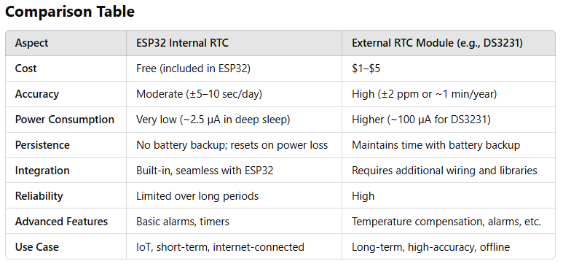

**Which One to Use?**

1. **Use ESP32 Internal RTC When**:
   * Cost and simplicity are critical.
   * The system connects to the internet for periodic NTP synchronization.
   * The application has short timekeeping requirements.
   * Power efficiency is a priority, such as in battery-powered IoT devices.
2. **Use External RTC When**:
   * Accurate and persistent timekeeping is required.
   * The device operates in an offline environment.
   * Long-term data logging or scheduling is necessary.
   * Applications cannot tolerate clock drift (e.g., industrial systems or scientific measurements).

# **List of external RTCs of ESP32:**

# 1) DS3231 RTC Module:

RS: 750/-

<https://epro.pk/product/ds3231-rtc-real-time-clock-in-pakistan/#:~:text=DS3231%20Real%20Time%20Clock%20RTC,Price%20in%20Pakistan%20%7C%20Epro.pk&text=DC%20Brushless%20Fan%20(Stock%2DLot,Current%20price%20is%3A%20%E2%82%A8180>.

RS: 450/-

<https://digilog.pk/products/ds3231-rtc-module?srsltid=AfmBOoqB_edSfKgfJz-22dSNgsJMhBQ39hLiaNI2YSgkm93rDw0LQ-D7>

# 

A DS3231 RTC module is a highly accurate, low-cost real-time clock (RTC) that uses an I2C communication protocol to keep track of time, including seconds, minutes, hours, day, date, month, and year, with features like leap year compensation, all while maintaining timekeeping even when main power is interrupted due to its built-in battery backup, typically using a CR2032 coin cell; it is known for its precision thanks to an integrated temperature-compensated crystal oscillator (TCXO) that adjusts for temperature fluctuations, making it a popular choice for applications requiring accurate timekeeping across various environments.

**Key features:**

* **High Accuracy:** Can maintain time with accuracy within ±2ppm (parts per million) at standard temperatures (0°C to 40°C).
* **Temperature Compensation:** Built-in TCXO automatically adjusts for temperature changes, ensuring consistent timekeeping.
* **Battery Backup:** Can maintain time even when main power is lost using a small battery like a CR2032.
* **I2C Communication:** Simple interface to connect to most microcontrollers using the I2C protocol.
* **Alarm Functionality:** Can be programmed to trigger alarms at specific times.
* **Integrated Temperature Sensor:** Provides an additional feature to measure the ambient temperature.
* **Low Power Consumption:** Designed for minimal power draw, maximizing battery life.

# 2) DS1307 AT24C32 RTC Module:

RS: 150

<https://epro.pk/product/rtc-i2c-ds1307-at24c32-real-time-clock-module/>

RS: 250

<https://w11stop.com/ds-1307-rtc-module#:~:text=Description,243%2F%2D%20>.

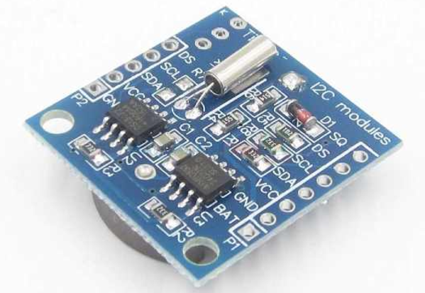

**Key features:**

* **I2C Communication:** Communicates with a microcontroller using the I2C protocol, allowing for easy data transfer between the module and the controlling device.
* **Battery Backup:** Contains a dedicated pin to connect a small battery, enabling the clock to keep time even when the main power supply is interrupted.
* **Calendar Functionality:** Tracks date and time information including seconds, minutes, hours, day of the week, date, month, and year.
* **Leap Year Compensation:** Automatically adjusts for leap years.
* **Low Power Consumption:** Operates with minimal power draw, making it suitable for battery-powered applications.
* **SRAM Memory:** Includes a small amount of non-volatile SRAM memory that can be used to store additional data alongside the timekeeping information.
* **Operating Modes:** Can operate in either 24-hour or 12-hour format with AM/PM indicator.

# 3) PCF8563 RTC Module:

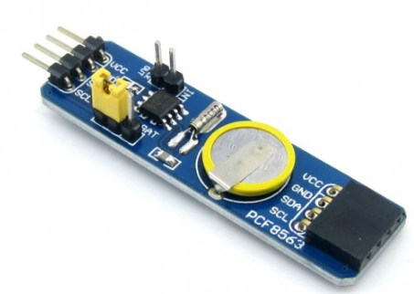

The PCF8563 RTC Board is CMOS real-time clock/calendar optimized for low power consumption. Programmable clock outputs interrupt outputs, and voltage low detectors are also provided.

All addresses and data are transferred serially via a two-line bi-directional I2C bus. The maximum bus speed is 400 kbit/s. The built-in word address register is automatically incremented after each data byte is written or read.

**Features:**

* Low-power RTC.
* Operates via I2C.
* Includes alarms, timers, and clock output functions.
* Compatible with a wide voltage range.
* Use Cases: Ideal for low-power and battery-operated devices.

# 4) PCF8523 RTC Module:

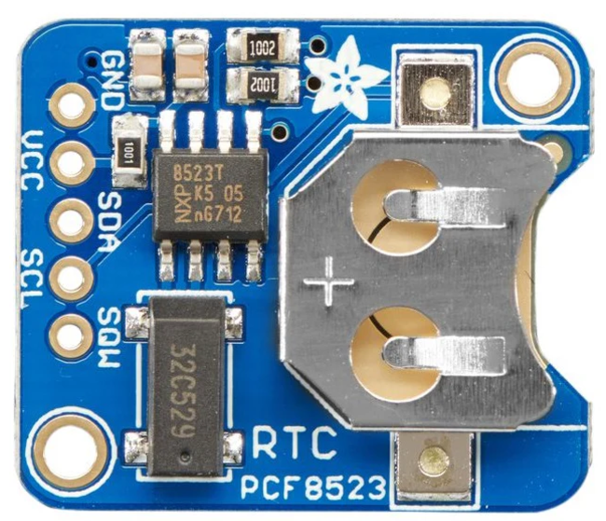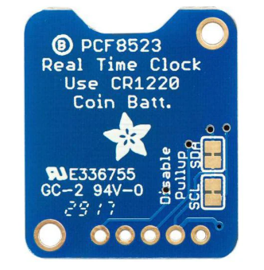

The PCF8523 RTC module from Adafruit is Real-Time Clock (RTC) and calendar optimized for low power consumption. Data is transferred serially via the I2C-bus. Alarm and timer functions are available with the possibility to generate a wake-up signal on an interrupt pin.

The PCF8523 has a built-in power-sense circuit that detects power failures and automatically switches to the backup supply. It can be used in many applications such as data logging, clock-building, time stamping, timers, calendars and alarms.

**Features:**

* Provides year, month, day, weekday, hours, minutes, and seconds based on a 32.768 kHz quartz crystal
* 3.3 or 5 V power supply voltage
* Low power consumption
* I2C Serial Interface
* Low-cost RTC module with built-in temperature compensation.
* Alarms, timers, and clock output available.
* Advantages: Better suited for low-power applications than the PCF8563.
* Use Cases: Portable devices requiring basic timekeeping with moderate accuracy.

**5) RV-3028-C7** RTCModule

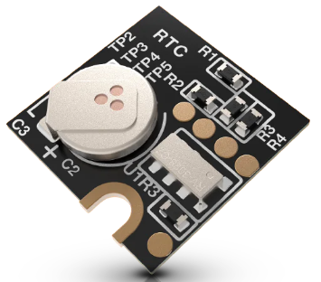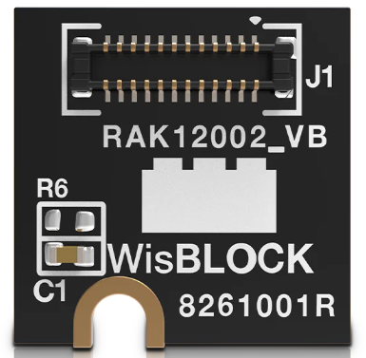

**RV-3028-C7** is a SMT Real-Time Clock Module that incorporates an integrated CMOS circuit together with an XTAL. It operates under vacuum in a hermetically sealed ceramic package with metal lid.

The **RV-3028-C7**real-time clock/calendar module with an automatic backup power switchover circuit is optimized for **extreme low power consumption**. It provides full RTC function with programmable counters, alarm, selectable interrupt and clock output functions and also a 32-bit UNIX Time counter. The internal EEPROM memory hosts all configuration settings and allows for additional user memory. An EEPROM Offset value allows compensating the frequency deviation of the 32.768 kHz clock.

**Features**:

* Ultra-low-power RTC.
* High accuracy with temperature compensation (±1 ppm at 25°C).
* I2C and SPI interfaces.
* Battery backup.
* Advantages: Extremely energy-efficient, ideal for energy-sensitive applications.
* Use Cases: Wearable devices, IoT applications.

6) MCP7940N RTCModule:

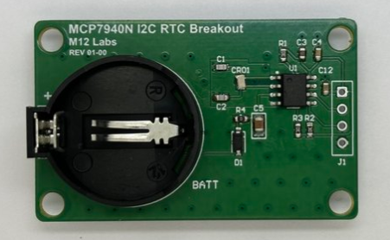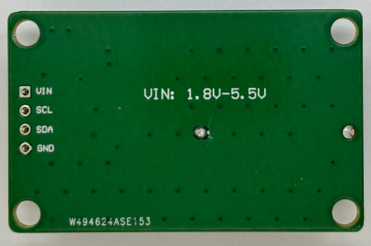

**Features:**

* Integrated EEPROM for user data.
* Supports alarms.
* Advantages: Combines RTC and EEPROM, simplifying designs.
* Use Cases: Projects needing RTC and small non-volatile storage.
* Comprehensive Timekeeping: Tracks seconds, minutes, hours, day of week, day, month, and year, including leap year compensation up to 2399.
* 12/24 Hour Modes: Ability to switch between 12-hour and 24-hour time formats.
* On-chip Calibration: Integrated digital trimming mechanism for improved time accuracy.
* High Interface Speed: Supports up to 400 kHz I2C communication speed.
* Low Power Consumption: Designed for battery-backed applications with minimal power draw.
* Wide Operating Temperature Range: Can function in environments from -40°C to 125°C.
* Compact Package: Comes in an 8-pin package, making it suitable for space-constrained designs.
* Automotive Grade: Considered reliable for demanding automotive applications.

7) DS2417 RTCModule:

<https://www.mikroe.com/rtc-4-click>

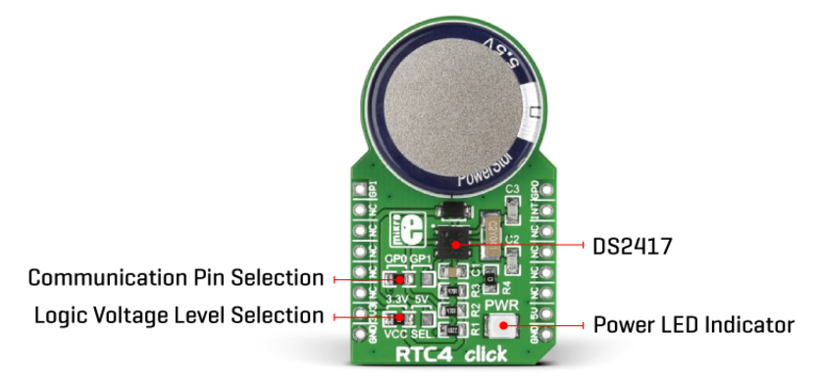

**Features:**

* RTC with a 1-Wire interface.
* Programmable clock output for synchronization.
* Use Cases: Applications where a single-wire communication interface is beneficial.

8) AM1805 RTCModule:

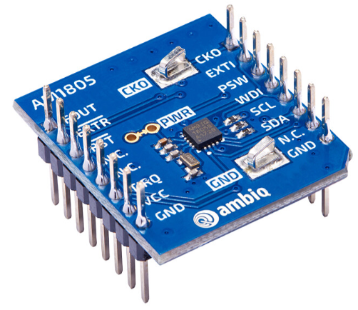

The AM1805 includes on-chip oscillators to provide minimum power consumption, full RTC functions including battery backup and programmable counters and alarms for timer and watchdog functions, and a I2C serial interface for communication with a host controller.

**Features:**

* High accuracy with internal oscillator.
* I2C/SPI communication.
* Low power consumption.
* Advantages: Suitable for both low-power and industrial applications.
* Use Cases: Industrial automation and IoT devices.

9) AM1805 RTCModule:

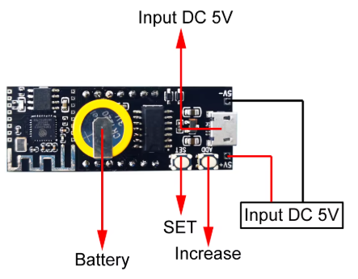

**Key Features:**

* Built-in 32.768kHz crystal unit : Frequency adjusted for high accuracy(±5x10-6 / Ta=+25°C)
* Interface Type : I2C-Bus interface (400kHz)
* Operating voltage range : 1.70V to 5.5V
* Wide voltage for timekeeping : 1.15V to 5.5V
* Various detection Functions : Ex. Oscillation stop detection function
* Low backup current : 0.48µA / 3V (Typ.)
* 32.768kHz frequency output function : C-MOS output with OE pin
* The various functions include full calendar,Dual alarm, Periodic interruption

10) ChronoDot RTCModule:

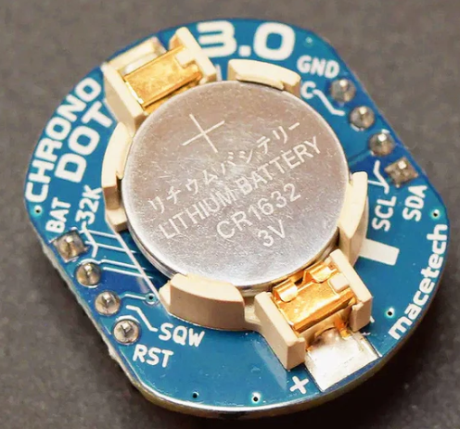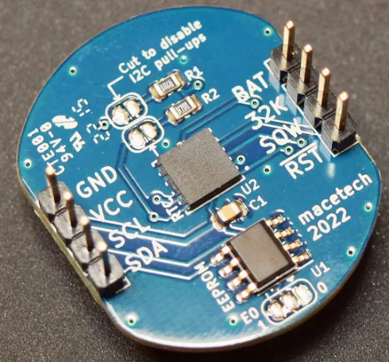

**Features:**

* Uses DS3231 IC.
* High-precision RTC with battery backup.
* Pre-assembled module for easy integration.
* Advantages: High accuracy and ease of use.
* Use Cases: Prototyping and DIY electronics projects.

**Comparison Table Of Different RTC Modules**

|  |  |  |  |  |  |  |  |  |  |  |
| --- | --- | --- | --- | --- | --- | --- | --- | --- | --- | --- |
| **Feature** | **DS3231** | **DS1307** | **PCF8563** | **PCF8523** | **RV-3028-C7** | **MCP7940N** | **DS2417** | **AM1805** | **RX8025** | **ChronoDot** |
| **Accuracy** | ±2 ppm (0°C to 40°C) | ±20 ppm | ±5 ppm (at 25°C) | ±5 ppm (at 25°C) | ±1 ppm (at 25°C) | ±10 ppm (typical) | ±20 ppm | ±2 ppm | ±3 ppm | Same as DS3231 (±2 ppm) |
| **Power Consumption** | ~200 nA (battery mode) | ~300 nA (battery mode) | ~250 nA (typical) | ~120 nA (typical) | ~45 nA (battery mode) | ~1.2 µA | ~1 µA | ~150 nA | ~400 nA | Same as DS3231 (~200 nA) |
| **Battery Backup** | Yes | Yes | Yes | Yes | Yes | Yes | Yes | Yes | Yes | Yes |
| **Interface** | I2C | I2C | I2C | I2C | I2C, SPI | I2C | 1-Wire | I2C, SPI | I2C | I2C (as it's based on DS3231) |
| **Operating Voltage** | 2.3V–5.5V | 4.5V–5.5V | 1.8V–5.5V | 1.8V–5.5V | 1.5V–5.5V | 1.8V–5.5V | 2.8V–5.5V | 1.8V–5.5V | 1.8V–5.5V | Same as DS3231 (2.3V–5.5V) |
| **Temperature Compensation** | Yes | No | No | Yes | Yes | No | No | Yes | Yes | Yes |
| **Alarms** | 2 alarms | 2 alarms | 2 alarms | 2 alarms | 2 alarms | 2 alarms | No | 2 alarms | 2 alarms | Same as DS3231 (2 alarms) |
| **EEPROM/Memory** | None | 56 bytes user SRAM | None | None | None | 64 bytes EEPROM | None | None | None | Same as DS3231 (None) |
| **Square Wave Output** | Yes | Yes | Yes | Yes | Yes | Yes | Yes | Yes | Yes | Yes |
| **Temperature Range** | -40°C to +85°C | 0°C to +70°C | -40°C to +85°C | -40°C to +85°C | -40°C to +85°C | -40°C to +85°C | -40°C to +85°C | -40°C to +85°C | -40°C to +85°C | Same as DS3231 (-40°C to +85°C) |
| **Package Type** | Module/IC | Module/IC | Module/IC | Module/IC | Module/IC | Module/IC | IC | Module/IC | Module/IC | Pre-assembled module with DS3231 |
| **Typical Use Cases** | High-precision timekeeping | Basic timekeeping | Low-power devices | Low-power devices | Energy-efficient devices | RTC + storage | Single-wire systems | Industrial systems | Compact devices | Prototyping, DIY projects |